Lesson: Measuring fuel (carbon) storage on forest floors.
Materials:
- Meter tape (25-100m length)
- DBH tape (diameter at breast height to measure diameter of 1000 – hr fuels)
  - A standard measuring tape may be used by measuring circumference, then multiplying by 0.3183 to yield diameter
- Caliper(s) or ruler (used for measuring fallen debris)
- Data sheet(s) (provided below)
- Access to computers for data entry and analysis (usually in Excel)

This lesson will allow students to conduct field ecology work, record and interpret data, and develop graphic analysis skills. The lesson is a great way to get students outdoors to collect real data and to use mathematics skills to analyze the data they have collected.
The overall goal is to measure how much fuel lies on local forest floors while getting an introduction to Critical Zone Science by observing interactions between the geosphere, biosphere, and atmosphere. Extensions to this lesson include but are not limited to, topographic map reading/interpreting, orienteering (compass), and tree identification.

Field Module
To begin, a transect line will be established to set up a study area. This can be any length the classroom teacher desires (recommended 25-100 meters in length). Once the line has been laid, fuels (time-lag class) measurements can be performed. Time lag is the amount of time necessary for a fuel to lose approximately 60% of its initial moisture content and reach its equilibrium moisture content (that which closely matches the atmospheric moisture content).
Begin by recording the number of 1-hour and 10-hour fuels between 0 and 2 meters on the transect line. This is to be repeated every 25 meters along the transect line when it is longer than 25 meters. For example, for a 100-meter long transect, measurement of 1-hour and 10-hour fuels will be done from 0-2 meters, 25-27 meters, 50-52 meters, and 75-77 meters. To record the information place tally marks in the correct columns on the data sheet provided. (The diameters for 1-hour fuels range between 0.1 - 0.64 cm or 0.393 – 0.25 inches, and 10-hour fuels range between 0.64 – 2.54 cm or 0.25 – 1 inch respectively).
100-hour fuels will be recorded (tallied) along a 4-meter transect repeating every 25 meters. For example, for a 100-meter long transect, measurements should be taken between 0-4 meters, 25-29 meters, 50-54 meters, and 75-79 meters. This measurement will be made with the 1-hour and 10-hour fuel measurements. Tally this in the appropriate column on the data sheet provided. (The diameter of 100-hour fuels ranges between 2.54 – 7.62 cm or 1 – 3 inches respectively).
1000-hour fuels will require more information to be recorded. This measurement is conducted along the entirety of the transect line regardless of the total length (from beginning to end). Any woody debris measuring greater than 7.62 cm (3 inches) should be recorded. First, the distance along the transect must be recorded (position at which the debris intersects the transect). Next, the species of tree should be identified if possible. If the debris has decayed such that species identification is not possible, record whether it is deciduous (hardwood) or evergreen (softwood). Decay class should be measured next. This observation is rated on a scale of 1 – 5 (1 being freshly downed tree with bark still intact, as if it is still alive; decay class 5 describes debris that is barely recognizable as a fallen tree and may have the consistency of soil. See “Log Decomposition Class” below).
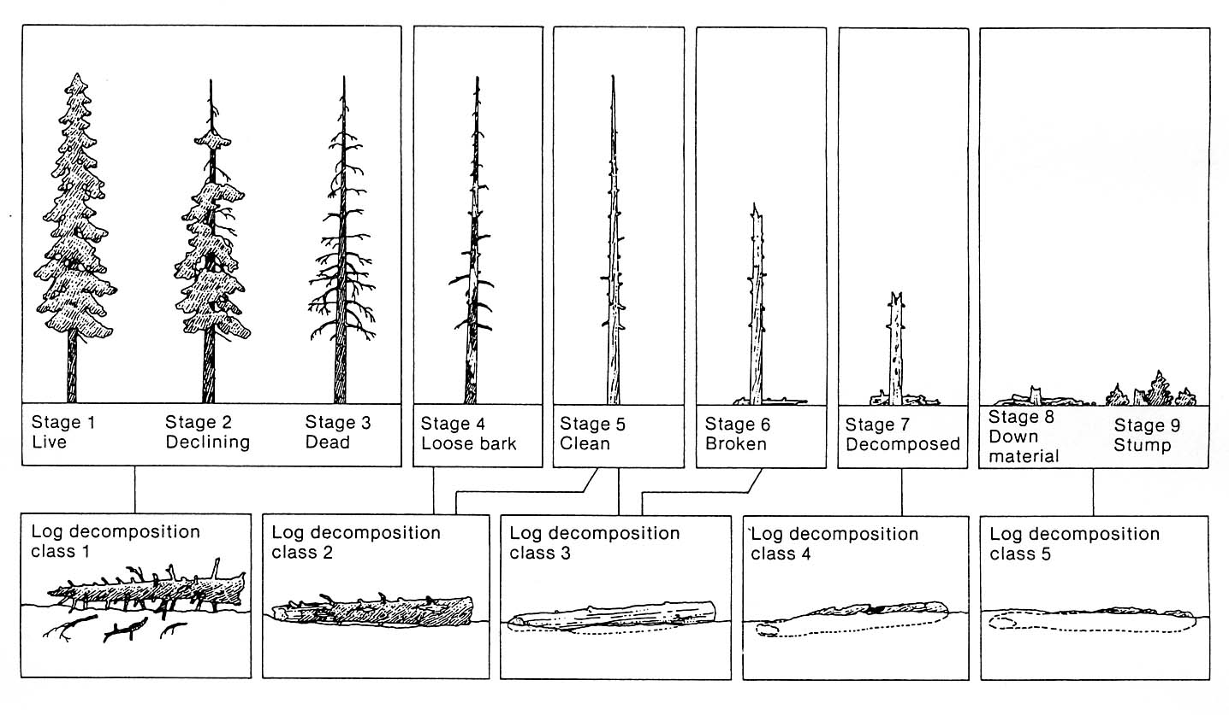
The final measurement for the 1000-hour fuels should be the length of the fallen debris. Using a meter tape, secure it to one end of the fallen debris (if working with a partner, have that person hold the end of the tape directly over the end of the debris) and measure the total length of the debris in meters. Below is an example of what raw field data could look like from your students.
Date: 7-Sept-2014 |  |  | Site: Example Site |  |  | Transect: 1A – 1B
1 hr | 10 hr | 100 hr | 1000 hr | Species | Azimuth | Dist. On Line | Diam. | Decay Class | Length
llll | ll | l | l | Birch | 186 | 27 m | 11 cm | 2 | 4.5 m
 |  |  | l | Deciduous | 0 | 31.5 m | 15 cm | 2 | 1.3 m
 |  |  | l | Chestnut Oak | 92 | 47.8 m | 24 cm | 3 | 22.7 m
 |  |  | l | Red Maple | 56 | 77 m | 8 cm | 3 | 6 m

Analysis Module
Once sufficient data has been gathered, students should enter their data into an Excel spreadsheet in preparation for data analysis. For example:
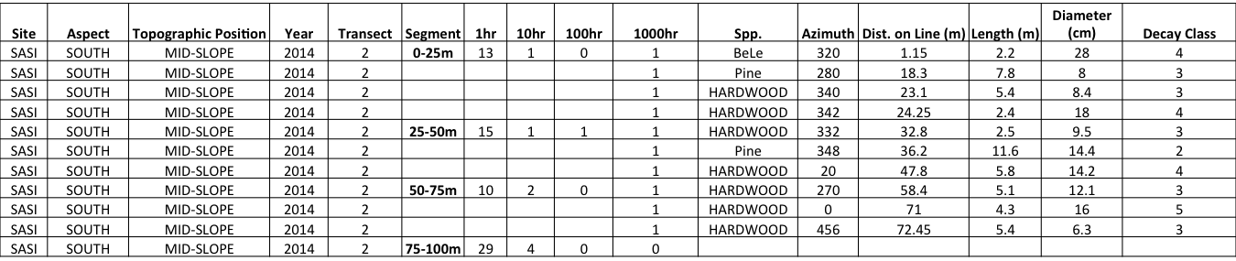

Calculations
Fuel loading measurements
n = # of intersections in transect (measured in field)
d² = squared average diameter of time-lag class in inches (if metric, conversion needed)
s = specific gravity of time-lag class
c = non-horizontal angle correction factor
a = slope correction factor (most often “1” is used for this value unless a specific slope correction factor has been calculated for your specific site)
N_{i} = total length of sampling line for time lag

Time-Lag Class | n | d² | s | a | c | N_{i}
1 – hour |  | 0.0151 | 0.48 | 1 | 1.13 | 6 (ft)
10 – hour |  | 0.289 | 0.55 | 1 | 1.13 | 6 (ft)
100 – hour |  | 2.76 | 0.55 | 1 | 1.13 | 15 (ft)
1000 – hour sound | n/a |  | 0.65 | 1 | 1 | Length of transect (ft)
1000 – hour rotten | n/a |  | 0.45 | 1 | 1 | Length of transect (ft)

1/10/100 – hour fuels calculation - (11.64*n*d²*s*a*c)/N_{i}

1000 – hour fuels calculation – (11.64*Σ d²* s*a*c)/N_{i}

Once these calculations have been completed, you must sum all the values to obtain your total fuel load (in tons/acre). Students can then compare/contrast this data with any other data collected from any number of different sites or transects. Shown below are 1000 – hour fuel loads from two different research sites as an example of how the data can be used to create column graphs.

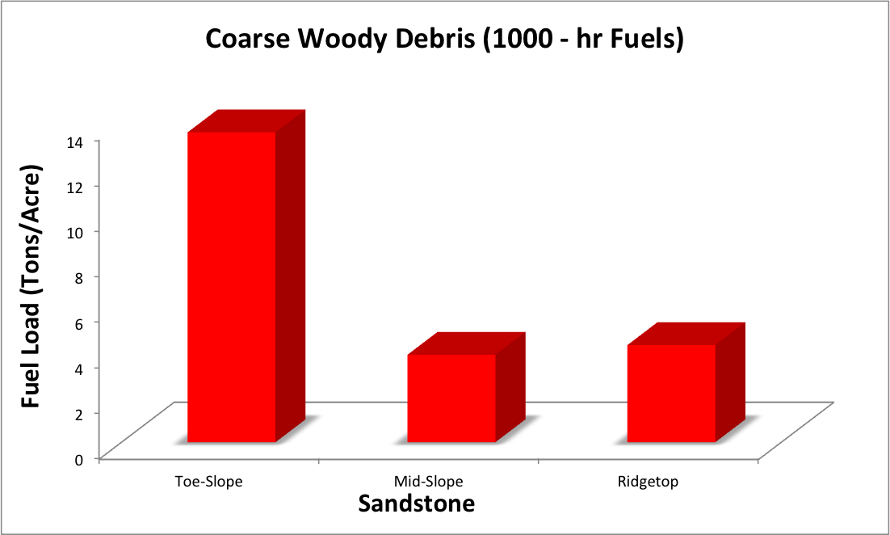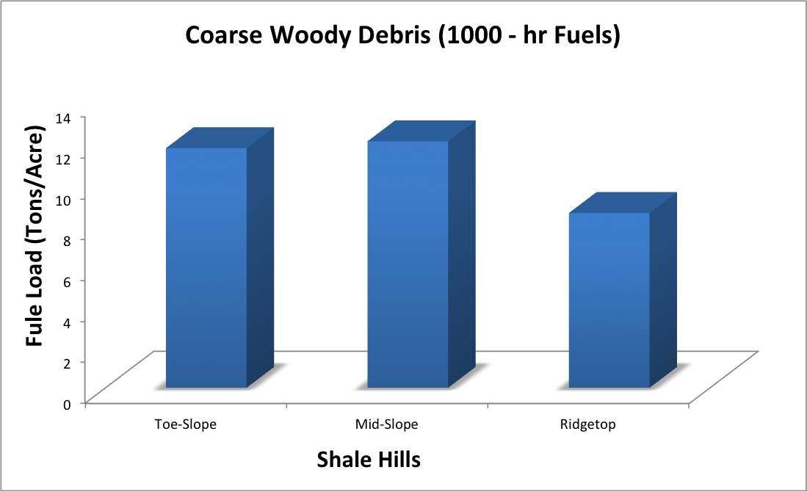

Rationale:
This type of lesson provides an opportunity for secondary students and teachers in North America to build data sets for analysis across different climate zones. This data can be used to better understand the role of forests in the carbon cycle, managing forests for fires, and what roles both play within a forest’s ecosystem.
The following link is to an example of how data can be used to compare forests in different geographic regions. The article compares coarse woody debris in a Chinese old growth deciduous forest and an old growth coniferous forest in Oregon. http://andrewsforest.oregonstate.edu/pubs/pdf/pub1180.pdf

